
STUDENT CASE STUDY EXECUTION REPORT
Department | FED
Subject | DSA – 2
Academic Year | I-III Semester (2025 – 26)
Faculty Name | Ms. Mamatha
Student Name | Uppalapati Venkata Naga Varshitha
Roll Number | 2520030206
Branch | CSE
Course Outcome | CO 2 – Multiway Trees & Query Structures

Case Study Title: Warehouse Inventory Analytics using Segment Trees in SmartLogix

Problem Statement:
SmartLogix warehouses manage thousands of inventory updates daily. Efficient analytics are required to calculate delivery volume and inventory movements over specific time intervals.
In this case study, Segment Trees are used to efficiently process range sum queries and inventory updates.

Objectives:
- Implement Segment Tree for inventory analytics
- Perform range sum queries
- Update inventory values efficiently
- Analyze delivery volume over intervals
- Improve warehouse analytics performance

Algorithm Used:
Segment Tree is a tree-based data structure used for efficient range queries and updates.
Operations Performed: Tree Construction, Range Sum Query, Inventory Update

Code Implementation:
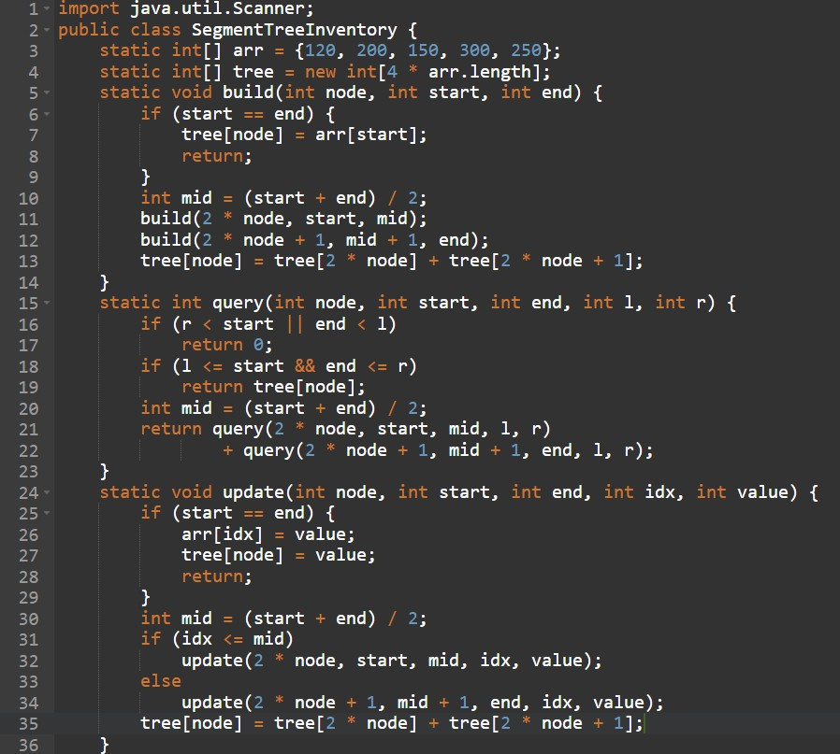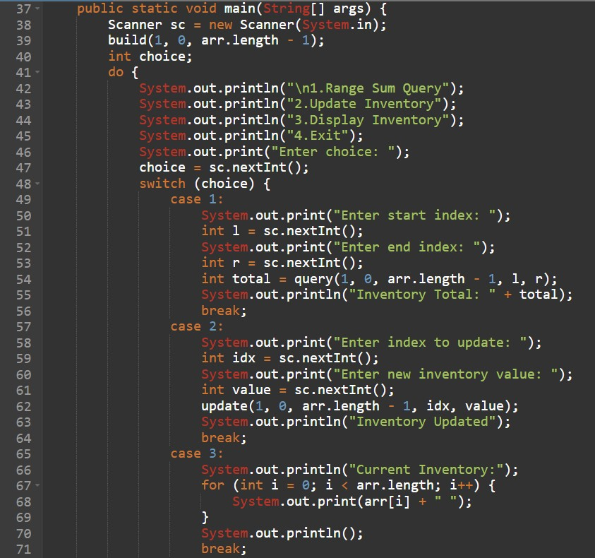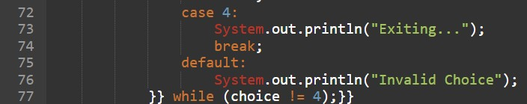

Sample Output:
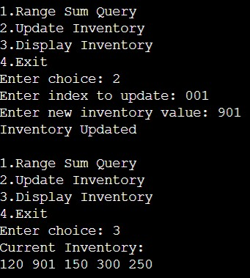

Result:
The Segment Tree efficiently processed inventory analytics and range queries. The implementation improved performance for warehouse inventory tracking and enabled fast inventory updates.
Time Complexity:
- Build Segment Tree: O (n)
- Range Sum Query: O (log n)
- Update Operation: O (log n)
- Display Inventory: O (n)

Advantages:
- Fast range query processing
- Efficient inventory updates
- Optimized analytics calculations
- Suitable for large-scale warehouse systems

Applications:
- Inventory movement analysis
- Warehouse stock monitoring
- Delivery volume analytics
- Logistics data processing

Conclusion:
This case study demonstrated the use of Segment Trees in SmartLogix for inventory analytics. Segment Trees improved query performance and enabled efficient logistics data analysis.

Github Link: https://github.com/srinivasvarshi7-beep/DSA-2-Casestudy.git

Student Signature: | Faculty Signature:

